Cancel ManualQuote (When PAR down / User logout / Product state change / Failover)

Overview

Current processing
Currently, ManualQuotes coming to CBOEDirect through PAR are not actively cancelled. Instead, a timer is set for each ManualQuote when it is received by CBOEDirect. If the ManualQuote is not processed, when the timer expired, it is automatically cancelled.

New requirement
- ManualQuote changes from quote-like to order-like. New ManualQuote will be treated similar as quote-like-order once it rests in the book.
- PAR will submit new ManualQuote through CAS to OrderEntryService (OES) rather than through OHS-PAR adapter connection to ManualOrderMantenanceService (MOMS)
- No timer will be used for new ManualQuote. ManualQuote cancellation will be actively triggered under following conditions:
  - When PAR station goes down/PAR user logs-out, all ManualQuotes associating with the PAR user will be actively canceled.
  - When the state of a product changes to CLOSED, HALTED or SUSPENDED, all ManualQuotes on this product will be actively canceled;
  - When CBOEDirect fails-over, all ManualQuotes will be actively canceled. Cancel reports will send back to PAR.

Design

    - Cancel ManualQuotes when PAR station goes down or PAR user logout
In the paradigm of new SPX linkage, ManualQuotes will be sent through CAS rather than PAR adapter. Following chart describes the flow of new ManualQuote handling.
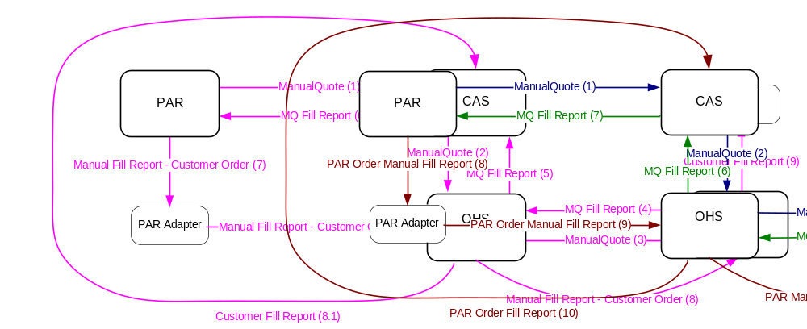
Figure 1. ManualQuote Handling for SPX Linkage

When PAR station goes down or PAR user logs out, ManualQuotes resting on TE, submitted by this PAR user, will be cancelled right away. However, there is no need to cancel ManualQuotes when PAR adapter or PAR server go down. Since the manual fill reports, generated at PAR from ManualQuote trades, can be cached in PAR server/adapter when the PAR server/adapter is down. The cached manual fill reports will sent to TE once the PAR server/adapter comes back.

  - When a PAR user logs out, CAS will detect this event and trigger SessionManagementService (SMS) to publish both logout event and user session close event. (Based on information from INFRA, in current implementation, only one user logs into one session and the session is closed when the user logs out.)
  - When a PAR station goes down, it will be detected by CAS. CAS will trigger SessionManagementService (SMS) to generate a session close event.

Both events will be consumed by OrderRoutingDestinationImpl, which implements SessionManagementServiceUserConsumer (see figure 1 below).
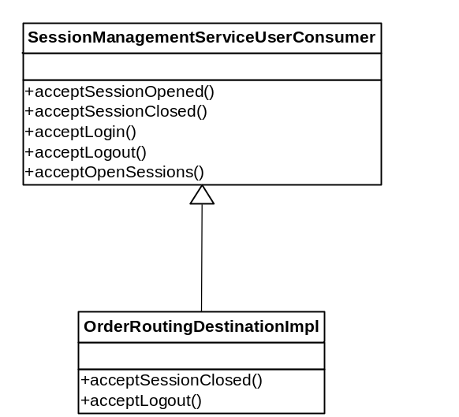

Figure 1. OrderRoutingDestinationImpl as consumer of user event.

Since session close event is triggered when either CAS session is closed (caused by PAR station down or any other reason) or PAR user loges-out, we need only implement logic in OrderRoutingDestinationImpl.acceptSessionClosed() method to cancel ManualQuotes of this PAR user.
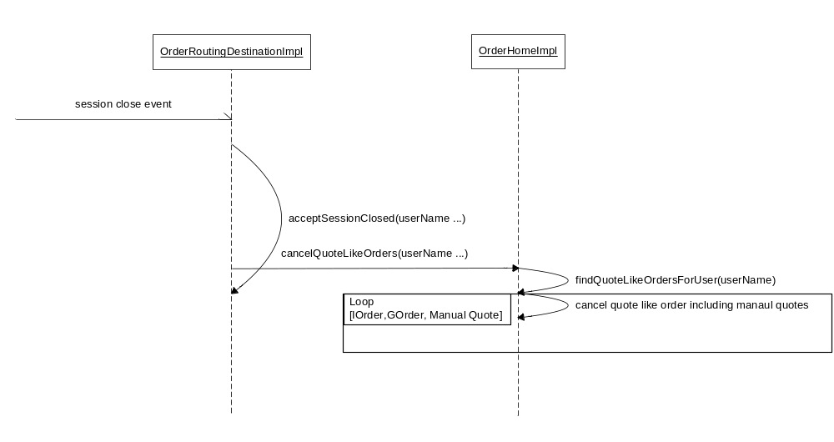
Figure 2. Cancel ManualQuotes when user session (CAS) close / user logs-out

- Cancel ManualQuotes when product state changes to CLOSED/HALTED/SUSPENDED.

When product state changes, a product state change event is published and consumed by OrderRoutingDestinationImpl, which implements TradingProductStateListener (see figure 3 below).

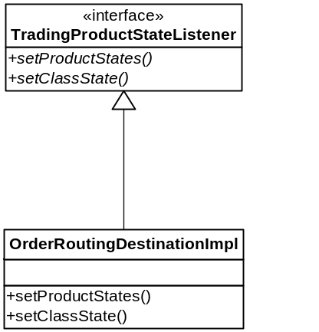

Figure 3. OrderRoutingDestinationImpl as consumer of product state change event.

OrderRoutingDestinationImpl listens product state change event and will trigger cancellation of quote-like-orders associating with this product, including ManualQuotes, if product state changes to CLOSED, HALTED or SUSPENDED.
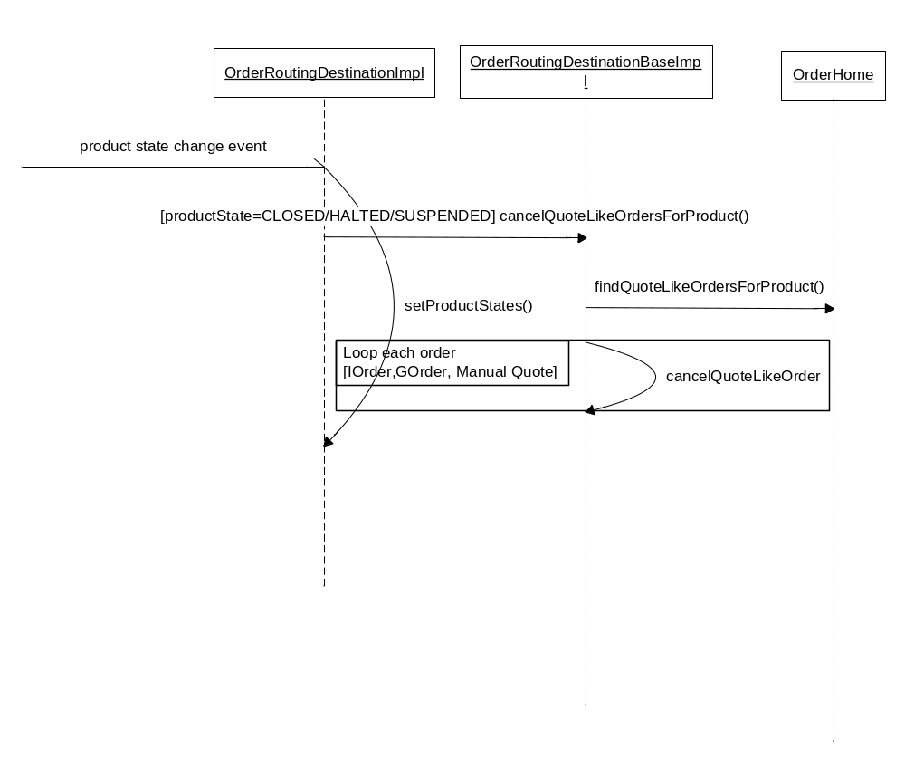Figure 4. Cancel ManualQuotes when product state changes

- Cancel ManualQuotes when fails-over
In current server configuration, OHS server sends periodical heart beats to TE server. Once TE server receives the hear beat, it knows that OHS server is up and running. When OHS server is down, it stops sending the heart beats to TE. Then, TE knows that OHS is down and TE will shut down itself. By other words, once OHS server is down, TE server will go down as well. Once OHS server or TE server goes down, fail-over kicks in. There are a few scenarios when fails-over could happen:
  - OHS is up but TE is down. In this case, TE will fail-over.
  - Both OHS server and TE serer are down. In this case, both OHS and TE will fail-over. In fail-over, OHS server will start first and run in master mode before TE get into master mode.
  - OHS server is down but TE is up. In this case, TE will shut down it self. Both OHS and TE will failover according to the order mentioned above.
In any case, OHS server has to be running in mast mode before TE can run in master mode. This order is critical for fail-over to perform correctly. Since TE does not directly access the orders persisted in database, in fail-over, TE always query OHS to retrieve the persisted orders to build order cache while canceling the orders that are not valid any more. The rebuilt order cache will be used to reconstruct order book.

In production, the current operation procedure asks to failover both OHS and TE servers event only TE server is down.

In current implementation, when failover, an order cancelable for fail-over could be cancelled by either OHS server or TE server depending on the type and contingency of the order. Here is the fail-over order cancel flow:

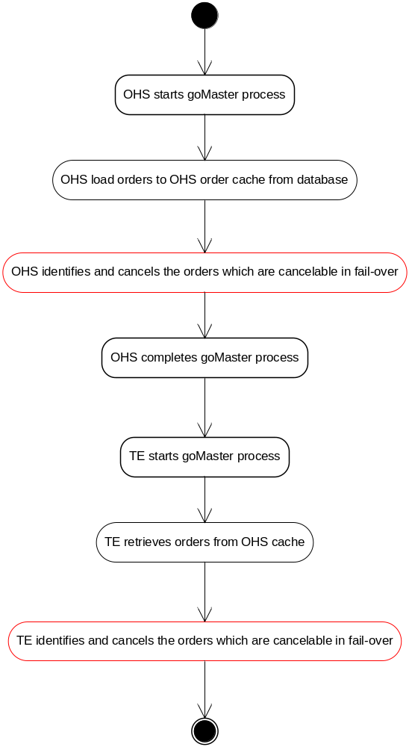

Figure 5. Cancel Orders when OHS and TE fail-over

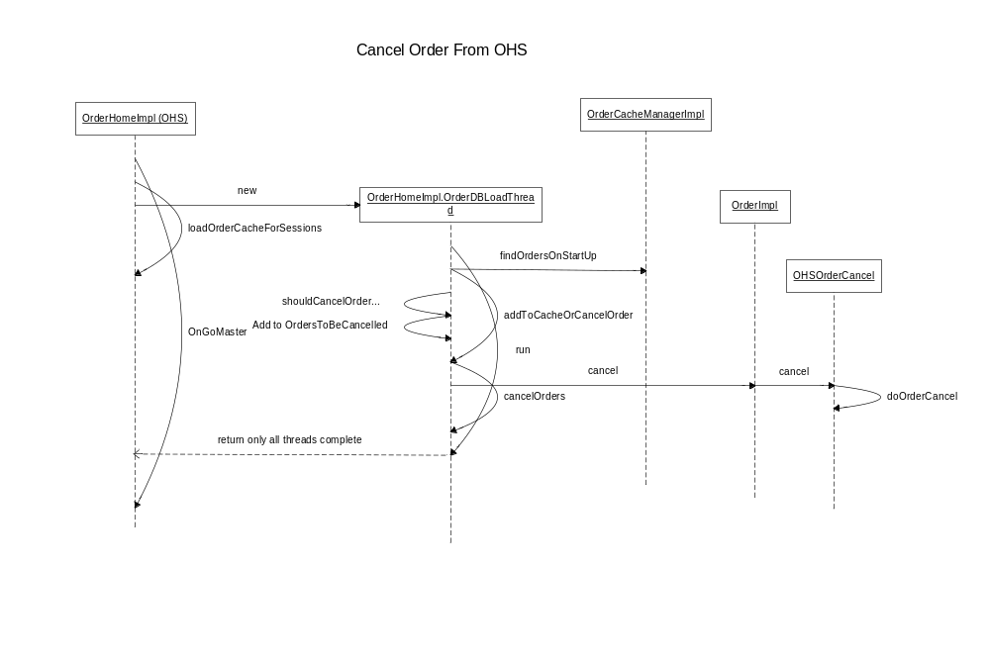Figure 5. Orders Cancellation at OHS in Fail-over

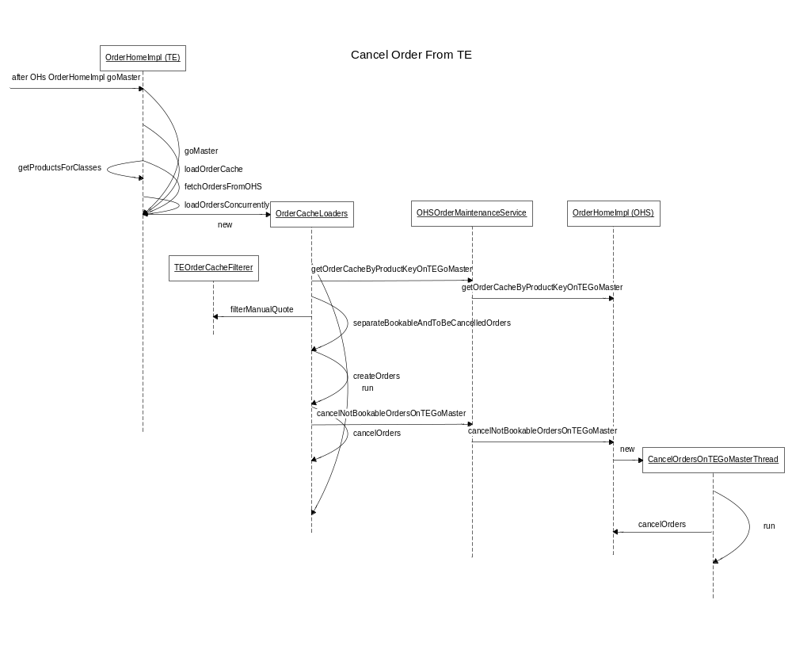 Figure 5. Orders Cancellation at TE in Fail-over

New requirements requires ManualQuotes to be canceled when fail-over happens. Based on the fail-over process described above and the existing practice, we decided to cancel all the unprocessed ManualQuotes at TE side only when order cache is loaded at each side.

Implementation

We will pig-back ManualQuote cancellation on existing quote-like-order cancellation process for following benefits:
- New ManualQuotes is acting very similar to quote-like-order after it rests in the book
- Doing so will minimize impact of code change to the existing system and reduce risk.

In this approach, a new ManualQuote will be inserted into existing quote-like-order cache in OrderHomeImpl. The cache provides benefits of fast retrieval for cancellation. When a ManualQuote is canceled, triggered byany reason, the ManualQuote will be removed from the cache.

Code Changes:

- Insert new ManualQuote to existing quoteLikeOrdersCache(OrderHomeImpl)
(code change is highlighted)

In OrderHomeImpl.addOrderToCache(OrderImpl order)
if (order.treatedLikeQuote() || isGOrder(order) || order.isManualQuote()
{
Map<Long, Order> quoteLikeOrdersByProduct = null;
synchronized (quoteLikeOrdersCache)
{
quoteLikeOrdersByProduct = quoteLikeOrdersCache.get(productKey);
if (quoteLikeOrdersByProduct == null)
{
quoteLikeOrdersByProduct = new ConcurrentHashMap<Long, Order>(23);
quoteLikeOrdersCache.put(productKey, quoteLikeOrdersByProduct);
}
}
quoteLikeOrdersByProduct.put(orderIdString, order);
}

- Delete ManaualQuote from cache
In OrderHomeImpl.deleteOrderFromCache method
public void deleteOrderFromCache(Order orderToBeDeleted)
{

……

// now delete from quoteLikeOrderCache
if (orderToBeDeleted.treatedLikeQuote() || isGOrder(orderToBeDeleted) || orderToBeDeleted.isManualQuote() )
{
// get the map of orders by product for IOrders
if (quoteLikeOrdersCache != null)
{
Map quoteLikeOrdersByProduct = quoteLikeOrdersCache.get(productKey);
if (quoteLikeOrdersByProduct != null)
{
quoteLikeOrdersByProduct.remove(orderIdLong);
}
}

}
}

- Cancel ManualQuotes when PAR goes down, PAR user logs-out
(See figure 2 for ManualQuote cancel flow)

In OrderHomeImpl.cancelQuoteLikeOrders()

public void cancelQuoteLikeOrders(String p_userName,
boolean p_systemCancel, short cancelReason)
throws TransactionFailedException, SystemException,
NotAcceptedException, DataValidationException {
int count = 0;
Order[] orders = findQuoteLikeOrdersForUser(p_userName);
if (orders != null && orders.length > 0) {
for (int j = 0; j < orders.length; j++) {
if (orders[j].isActive() && (orders[j].treatedLikeQuote()
|| isGOrder(orders[j])
|| order.isManualQuote() ){
orders[j].markCancelReason(cancelReason);
getBrokerService().acceptCancel(orders[j], 0,
OrderCancelTypes.CANCEL_ALL_QUANTITY,
p_systemCancel ? OrderLocal.SYSTEM_CANCEL_ID : "");
count++;
}
}
}
if (count > 0) {
Log.information(this, "Cancelling I- orders from user logout "
+ p_userName + ". Total scheduled to cancel count: "
+ count);
}
}

- Cancel ManualQuotes when product state changes to CLOSED, HALTED or SUSPENDED.
(See figure 4 for ManualQuote cancel flow)
In OrderRoutingDestinationBaseImpl.cancelQuoteLikeOrder()

protected boolean cancelQuoteLikeOrder(Order orderToCancel, short cancelReason)
throws SystemException, DataValidationException, NotAcceptedException
{
if (orderToCancel.isActive() && (orderToCancel.treatedLikeQuote()
|| ((OrderHomeImpl)getOrderHome()).isGOrder(orderToCancel))
|| orderToCancel.isManualQuote()
{
// If the I-order is not localled booked and state is NOT suspended, then send cancel request.
//
orderToCancel.markCancelReason(cancelReason);
getBrokerService().acceptCancel(orderToCancel, 0, OrderCancelTypes.CANCEL_ALL_QUANTITY, "");
return true;
}
else if (orderToCancel.isActive() && orderToCancel.isAuctionResponse() &&
orderToCancel.isInvolvedInQuoteTrigger())//i.e. HALTrigger
{
orderToCancel.markCancelReason(cancelReason);
getBrokerService().acceptCancel(orderToCancel, 0, OrderCancelTypes.CANCEL_ALL_QUANTITY, "");
return true;
}
return false;
}
- Cancel ManualQuote when CBOEDirect fails-over

In TEOrderCacheFilterer.java, add a new filter method:
public static boolean filterManualQuote(OrderHandlingStruct order)
{
if (ExtensionsFieldParser.isManualQuoteEnabled(order.extensions)
|| ExtensionsFieldParser.isManualQuoteEnabled(order.optionalData) )
{
return true;
}
else
{
return false;
}
}
In OrderCacheLoaders.separateBookableAndToBeCancelledOrders() method, adding logic to cancel manual quote:

if (TEOrderCacheFilterer.filterAuctionResponses(orderStructs[i])
|| TEOrderCacheFilterer.filterExpressOrders(orderStructs[i])
|| TEOrderCacheFilterer.filterDerivedOrder(orderStructs[i])
|| TEOrderCacheFilterer.filterTimedOrders(orderStructs[i])
|| TEOrderCacheFilterer.filterOrdersTreatedLikeQuotes(orderStructs[i])
|| TEOrderCacheFilterer.filterCrossOrders(orderStructs[i])
|| TEOrderCacheFilterer.filterStockOddLotNBBOOnlyOrders(orderStructs[i]) || TEOrderCacheFilterer.filterCancelOnFailoverCloseHaltLogOutOrders(orderStructs[i])
|| TEOrderCacheFilterer.isQCTOrder(orderStructs[i])
|| TEOrderCacheFilterer.filterManualQuote(orderStructs[i]) )
{
ordersToBeCanceled.add(orderStructs[i].orderId);
}
else
{
bookableOrders.add(orderStructs[i]);
}

In com.cboe.ohs.domain.OrderHomeImpl.cancelOrders() memthod, add logic to cancel ManualQuote with trade report:

if (nextOrder.isInternalizedOrder()
|| nextOrder.isFirmMatchOrder()
|| nextOrder.isOrderSplitted()
|| nextOrder.isManualQuote())
{
nextOrder.cancel(…);
}
else
{
nextOrder.cancelWithoutReport(…);
}

NOTES:

- Backstop functionality cancel quote-like-order (I-order) if the I-order take too long (default is 3 seconds) to reach TE. Further research shows that this function should not affect ManualQuote, even the same cancellation codes are reused for new ManualQuote cancellation. The reason is that backstop functionality only apply to quote-like order while ManualQuote is not quote-like-order even it behaviors a lot similar to it.

Scripts
- None

Database
- None

SetContext

XML/DTD

Homes/Services
- OrderHomeImpl
- OrderRoutingDestinationBaseImpl

PerformanceTestingProcedure
- .

TestingProcedure

OperatorProcedure
- .

Fallback/Failover

